**TITLE: Demonstrate the Super Global Variables and File Uploading in PHP**

**AIM:** To understand various file operations and file upload in PHP

**Batch: C2**

**Roll No.: 16010122257**

**Experiment No. 07**

**Expected Outcome of Experiment:** Process external files in PHP.

# Books/ Journals/ Websites referred:

**Problem Statement: Description of the application implemented with output**:

# upload_form.html:

<!DOCTYPE html>

<html>

<head>

<title>File Upload Form</title>

</head>

<body>

<h2>Upload a File</h2>

<form action="upload.php" method="post" enctype="multipart/form- data">

<input type="file" name="fileToUpload" id="fileToUpload">

<input type="submit" value="Upload File" name="submit">

</form>

</body>

</html>

**upload.php:**

<?php

$targetDir = "C:/xampp/htdocs/lab/Exp7/uploads"; // Directory where uploaded files will be stored

$targetFile = $targetDir . basename($_FILES["fileToUpload"]["name"]); // Full path of the uploaded file

// Check if file was uploaded without errors

if (isset($_POST["submit"]) && !empty($_FILES["fileToUpload"]["name"])) {

$uploadOk = 1;

// Check file size (optional)

if ($_FILES["fileToUpload"]["size"] > 500000) { echo "Sorry, your file is too large.";

$uploadOk = 0;

}

// Allow only certain file formats (optional)

$allowedExtensions = array("jpg", "jpeg", "png", "gif");

$fileExtension = strtolower(pathinfo($targetFile, PATHINFO_EXTENSION));

if (!in_array($fileExtension, $allowedExtensions)) {

echo "Sorry, only JPG, JPEG, PNG, and GIF files are allowed.";

$uploadOk = 0;

}

// Check if $uploadOk is set to 0 by an error if ($uploadOk == 0) {

echo "Sorry, your file was not uploaded.";

} else {

// Attempt to move the uploaded file to the specified directory if (move_uploaded_file($_FILES["fileToUpload"]["tmp_name"],

$targetFile)) {

echo "The file " . htmlspecialchars(basename($_FILES["fileToUpload"]["name"])) . " has been uploaded.";

} else {

echo "Sorry, there was an error uploading your file.";

}

}

} else {

echo "Please select a file to upload.";

}

?>

# Output:

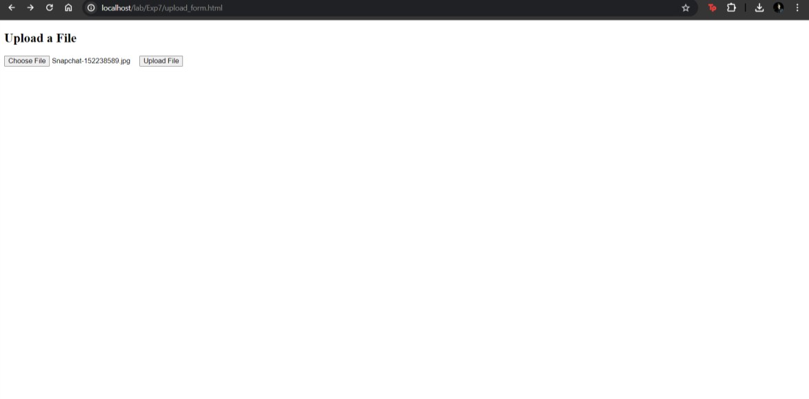

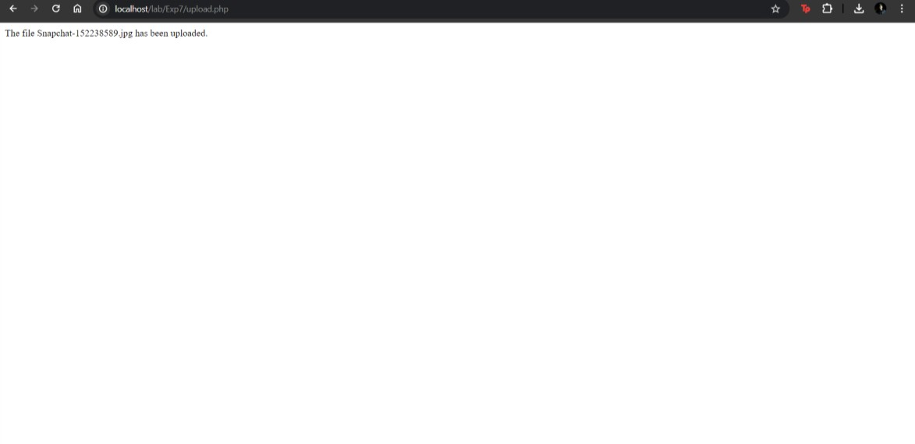

**Post Lab Questions:**

# 1. Perform following file operations with respect to problem statement/application:

Open, read and write with various modes, append, delete and downloading file.

# Answer:

Opening, Reading, and Writing with Various Modes:

Php

Copy code

$file = fopen("example.txt", "r+") or die("Unable to open file!"); // Open file for reading and writing

$content = fread($file, filesize("example.txt")); // Read file content fwrite($file, "New content added."); // Write to the file fclose($file); // Close the file

Appending to a File:

Php

Copy code

$file = fopen("example.txt", "a") or die("Unable to open file!"); // Open file for appending

fwrite($file, "Additional content appended."); // Append to the file fclose($file); // Close the file

Deleting a File:

Php

Copy code

if (file_exists("example.txt")) { unlink("example.txt"); // Delete the file echo "File deleted successfully.";

} else {

echo "File does not exist.";

}

Downloading a File:

Php

Copy code

$file = "example.txt"; if (file_exists($file)) {

header("Content-Type: application/octet-stream");

header("Content-Disposition: attachment; filename=" . basename($file)); header("Content-Length: " . filesize($file));

readfile($file); // Output the file exit;} else {

echo "File does not exist.";

}